**Warehouse Data Capture**

(WDC)

**User Manual**

**Document Information**

DOCUMENT CLASSIFICATION

|  |  |  |  |  |  |  |
| --- | --- | --- | --- | --- | --- | --- |
| **Criteria** | **Description** | | | | | |
| Classification |  | Public |  | Confidential |  | Restricted |

VERSION INFORMATION

|  |  |  |
| --- | --- | --- |
| **Version** | **Date** | **Description** |
| 1.0 | Jan 20, 2018 | Original Document |

REVIEW & RELEASE INFORMATION

|  |  |  |
| --- | --- | --- |
| **Date** | **Prepared / Modified by** | **Reviewed by** |
| Jan 20, 2018 | Sharad Gupta |  |

Table of Contents

Section 1: An Introduction 4

1.1 handheld application 4

Section 2: WDC - Admin 5

2.1 manage Location 6

2.2 Manage Unit 6

2.3 Manage Employee 7

2.4 Manage Customer 8

2.5 Manage Stock 9

2.6 Stock count sheet 10

2.7 Manage Vendor 12

2.8 manage purchase order 13

2.9 manage sales order 15

Figure 1 - Dashboard 5

Figure 2 - Manage location 6

Figure 3 - Warehouse Locations 7

Figure 4 - Create Employees 7

Figure 5 - View/Edit Employees 8

Figure 6 - Create Customer 8

Figure 7 - Create Stock 9

Figure 8 - View/Edit Stock 10

Figure 9 - Create Stock count sheet 10

Figure 10 - View Stock count sheets 11

Figure 11 - Create Vendor 12

Figure 12 - View/Edit Vendors 13

Figure 13 - Create Purchase order 13

Figure 14 - View/Edit Purchase order 14

Figure 15 - Assign Purchase Order to Employee 15

Figure 16 - Create Sale Order 15

Figure 17 - Assign Sale order to employee 16

# An Introduction

The Warehouse Data Capture software (hereafter referred as WDC) is aimed for inventory management of the warehouse and consists of following high level modules/functions :-

* 1. Receiving against ‘Purchase order’
  2. Issuing against ‘Sales order’
  3. Stock Take
  4. Wireless Sync from Motorola HHT app

‘Stock take’ allows the user to do the stock take inside the warehouse, against the provided stock count sheet (downloaded from Oracle)

All the selected count sheet numbers from PC application will be available for stock take in the HHT. User will select the stock count sheet from the HHT and then will start stock taking.

There could be following types of inventory items

* Items with only quantity
* Items with batch number and quantity
* Items with batch number and serial number
* Items with only serial number

## Handheld application

The handheld application is a windows application for HHT device that allows the user to do receipts, delivery and stock take using the HHT. Various modules of the HHT Data Collection application includes

1. User Login
2. Receipts (against PO)
3. Delivery (against SO)
4. Stock Take
5. Configuration

# WDC - Admin

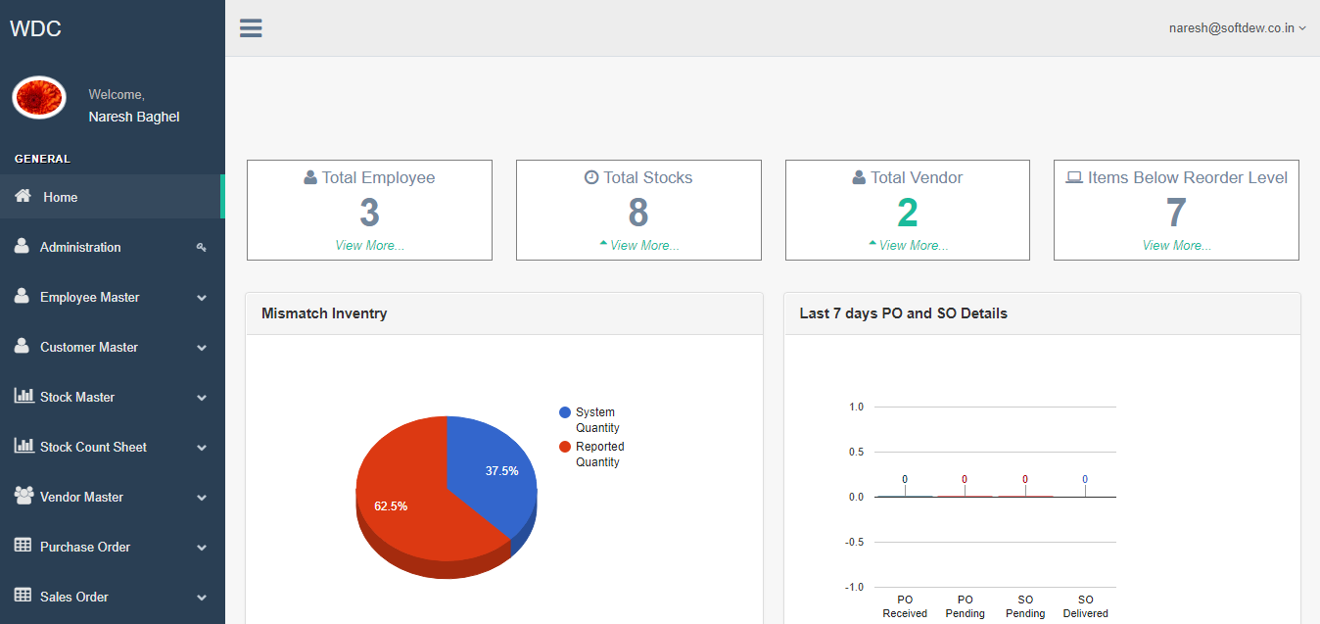

Figure 1 - Dashboard

In the dashboard , the admin will able to see the consolidated data like   
1) Total Employees, Total Stock , Total vendor , Items below recorder level   
2) Mismatch Inventory  
3) Last 7 days PO and SO details

## manage Location

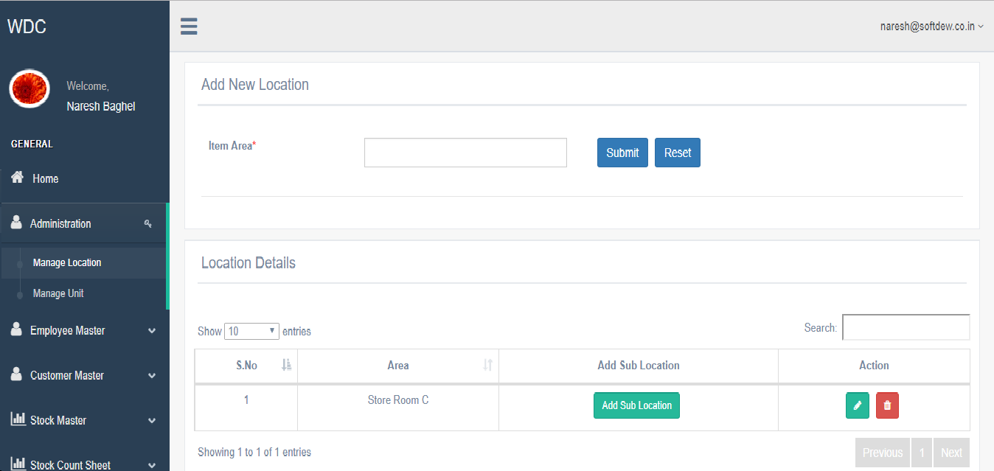

Figure 2 - Manage location

WDC Admin can create the warehouse location and also add the sub-location as well. With the provision to edit or delete the entries created.

## Manage Unit

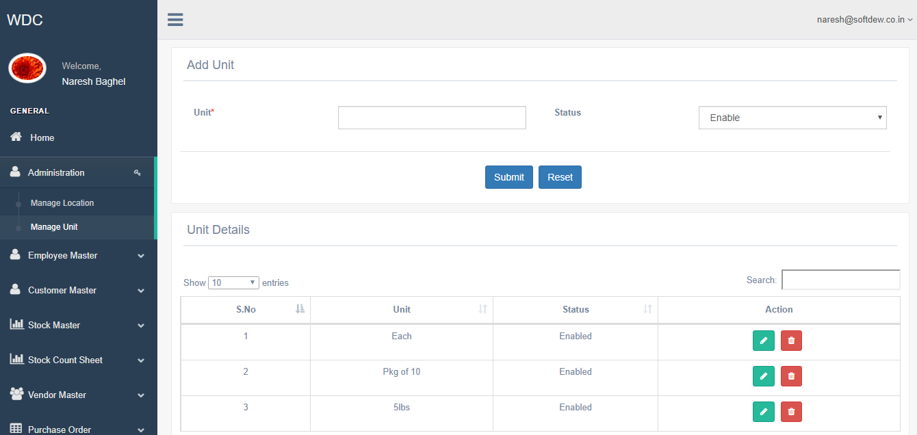

Figure 3 - Warehouse Locations

Under manage unit section , admin will able to define the units like weight , bundle size and likewise with the provision of edit and delete.

## Manage Employee

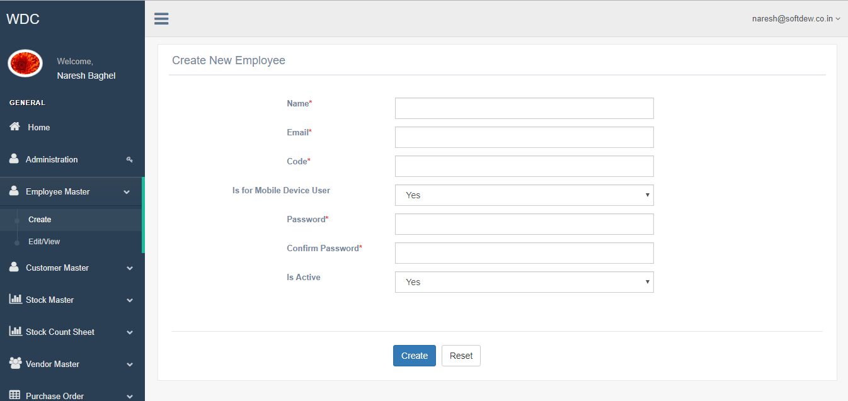

Figure 4 - Create Employees

Here, admin can create the new employees and specify if its for the mobile device user along with their unique code. The admin needs to fill following information:  
1) Name   
2) Email Id  
3) Code  
4) Password

5) Is user is for Mobile Device

Only if the employee is given access to mobile login, he will be able to login in HHT device

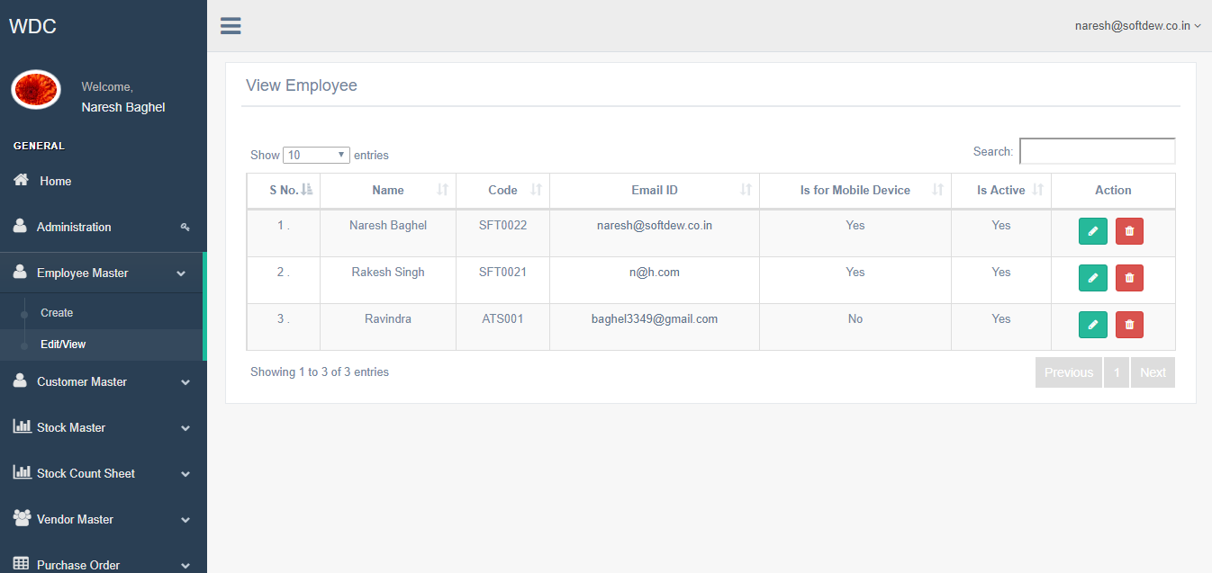

Figure 5 - View/Edit Employees

If there are any details which needs to be changed for the employee then admin can do that from here.

## Manage Customer

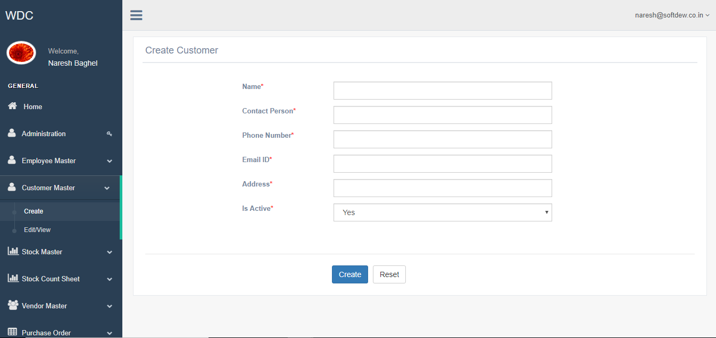

Figure 6 - Create Customer

In this section , the admin can able to create the new customers by filling the above set of information like :  
1) Name   
2) Contact person  
3) Phone number  
4) Email Id  
5) Address

## Manage Stock

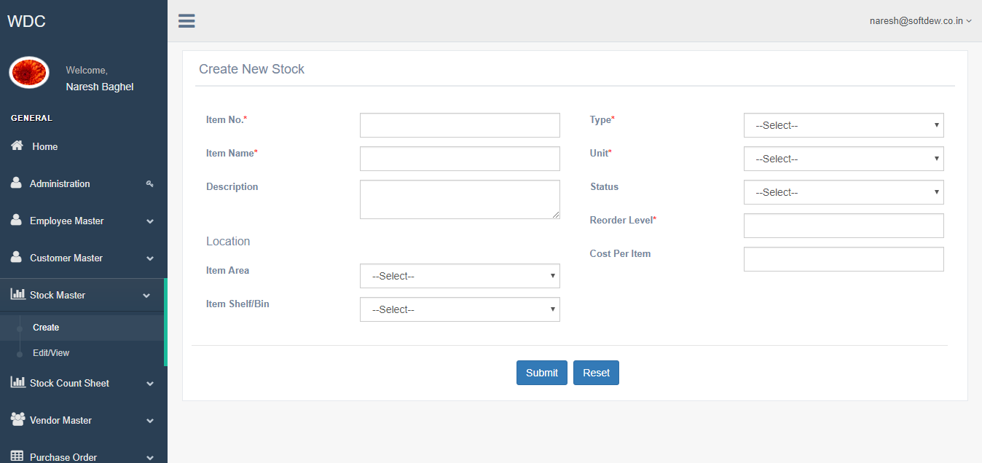

Figure 7 - Create Stock

In this section , the admin can able to create the New Stock and able to assign the Location created earlier. The following information will be required for creating new stock :

1) Item No. 2) Item Name 3) Description 4) Type  
5) Unit 6) Status 7) Re-Order Level 8) Item Area  
9) Item Shelf / Bin

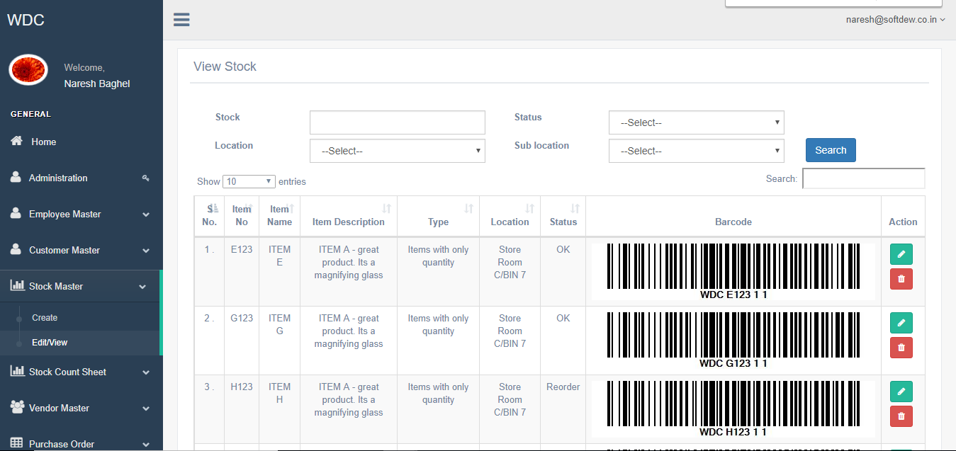

Figure 8 - View/Edit Stock

Here , admin can able to view the stock created and able to delete or modify the details added.

## Stock count sheet

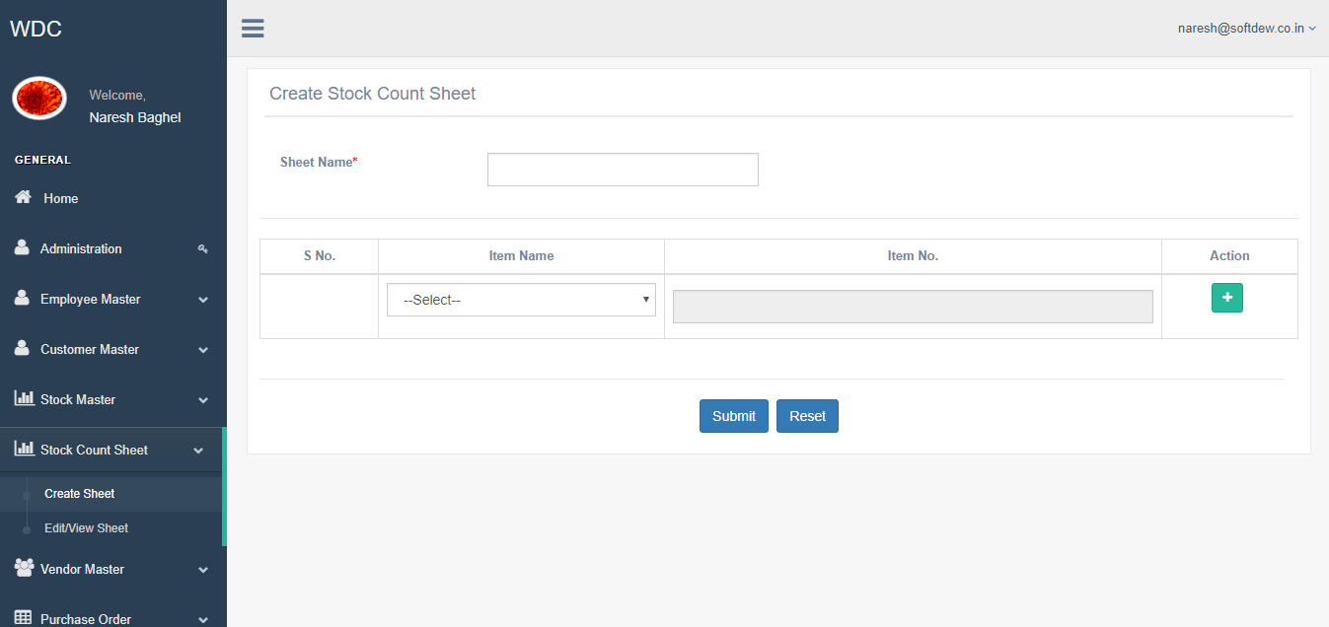

Figure 9 - Create Stock count sheet

In this section , admin will create the stock count sheet. Here admin will specify the Sheet Name and further can able to add the Items to the sheet.  
Admin needs to select the Item Name from the list and click on Add symbol to add the next item in the row.  
  
Once all items has been added then admin will click on the Submit button to create the new stock count sheet.

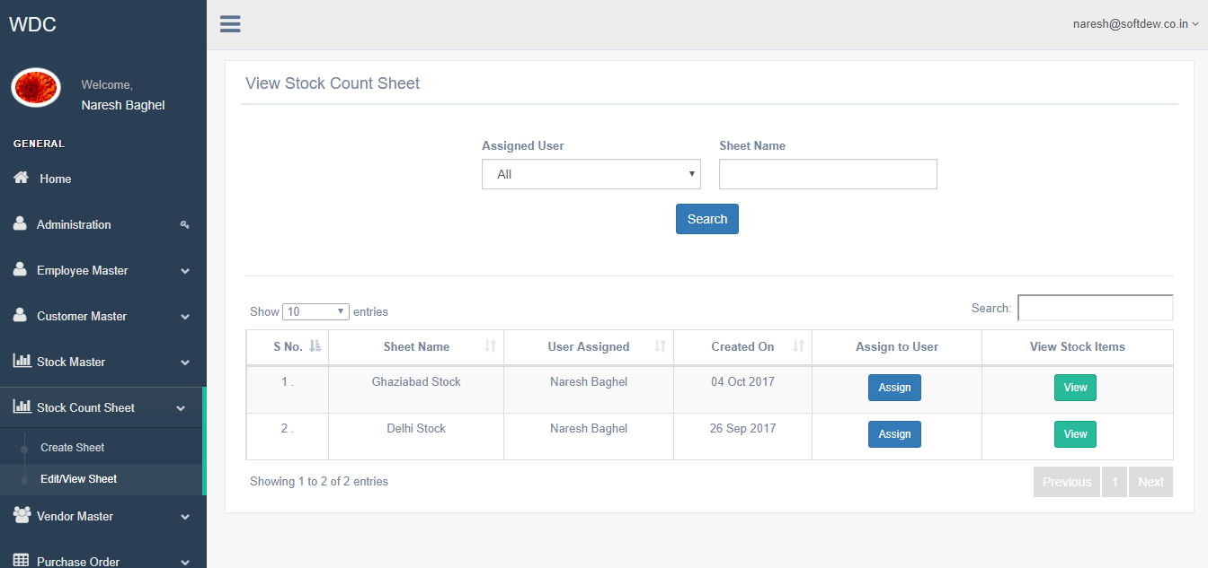

Figure 10 - View Stock count sheets

In this section , admin can able to see the stock count sheets created and has the provision to assign the sheet to the user/employee created earlier. In parallel the admin can always able to see the items of each stock count sheet as well.

## Manage Vendor

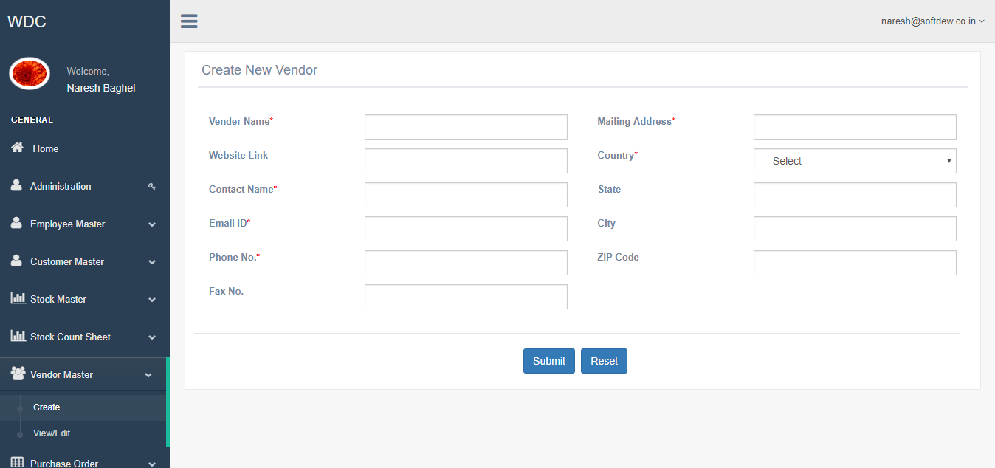

Figure 11 - Create Vendor

In this section , admin can able to add the new vendor. The following are the information required in order to create the new vendor .  
1) Vendor Name 2) Mailing Address 3) Website Link 4) Country  
5) Contact Name 6) State 7) EmaiI Id 8) City  
9) Phone No 10) Zip Code 11) FAX No.

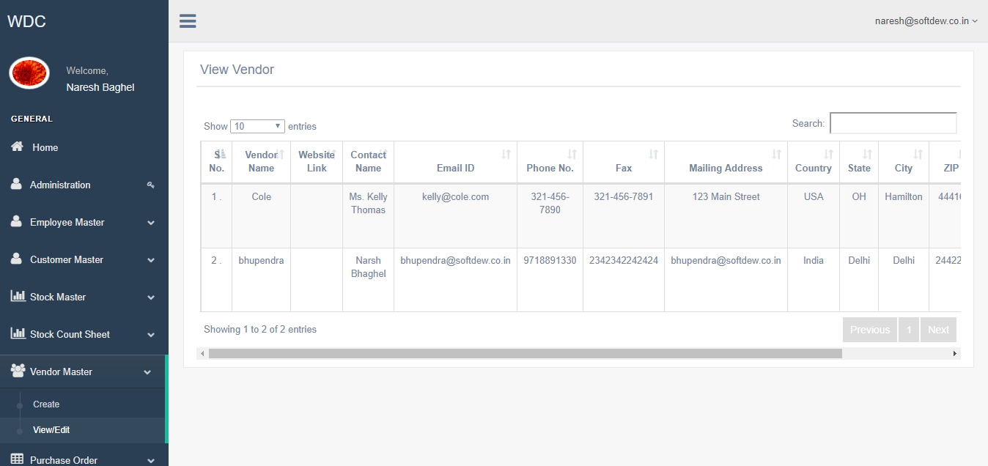

Figure 12 - View/Edit Vendors

In this section, admin can able to delete or modify the vendor details.

## manage purchase order

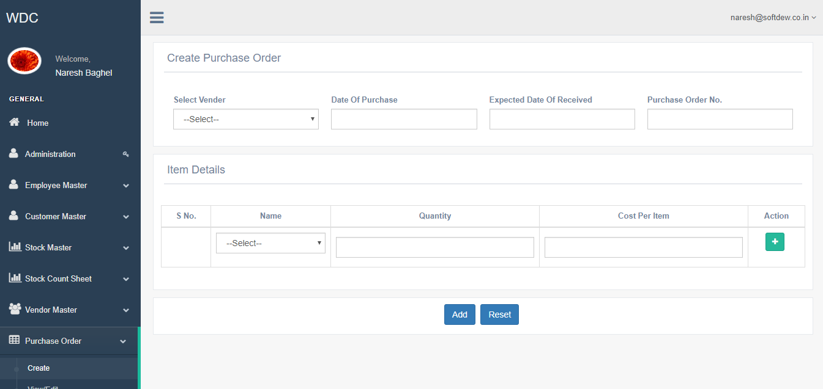

Figure 13 - Create Purchase order

In this section, admin can able to create the new purchase order. Admin need to select the vendor from the list along with the date of purchase, expected date of receiving the item along with the PO number.  
  
Further, admin will specify the items which will be there in the PO created. Once all items will get added in the PO then admin will click on Add button and final PO will get created.

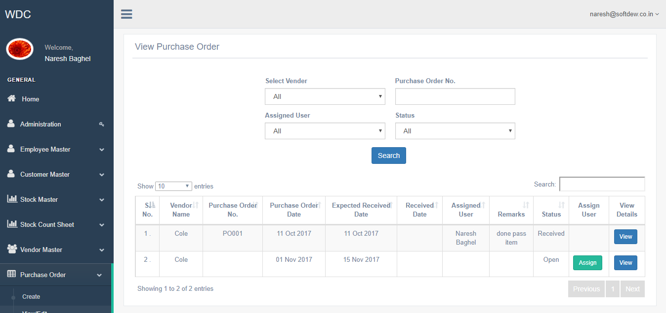

Figure 14 - View/Edit Purchase order

In this section, admin will able to view the details of the PO created. Along with this, admin can able to assign the PO to the user/employee. The same has been shown in the next slide.  
  
There will be filtering of the records basis the vendor selected from list, PO number , Assigned users and status.

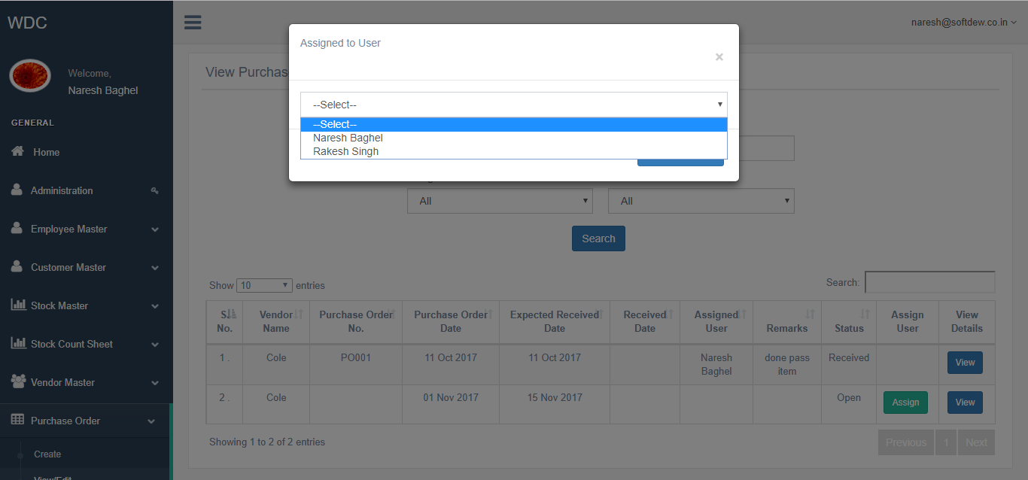

Figure 15 - Assign Purchase Order to Employee

When click on the Assign button against each PO, this pop up will get opened. Where admin will select the user from the list and allocate the PO to that particular user.

## Manage sales order

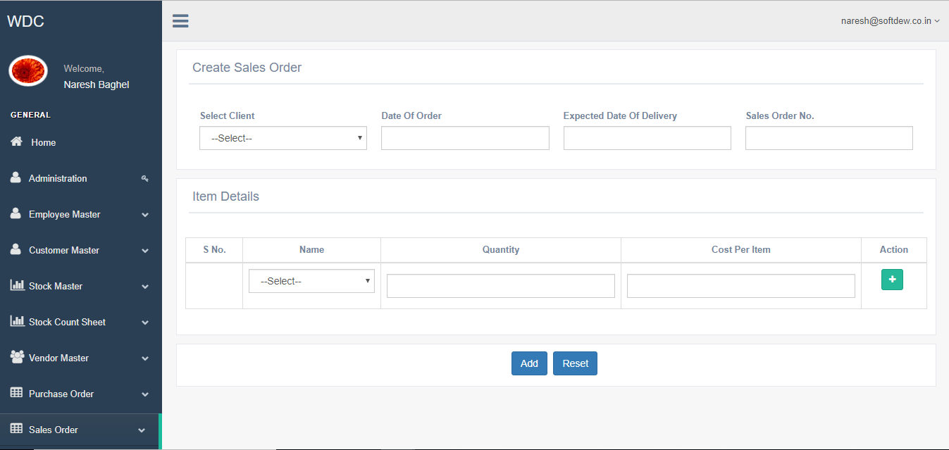

Figure 16 - Create Sale Order

In this section, admin will create the new sales order. For creating new order admin will select the client from the dropdown and specify the following:  
1) Date of order 2) Expected date of delivery 3) Sale Order No.  
  
Admin will also need to add the items to the orders by selecting the Order name, quantity and cost per item. In the same manner admin will add all items in the list and further click on Add button to create the new sales order.

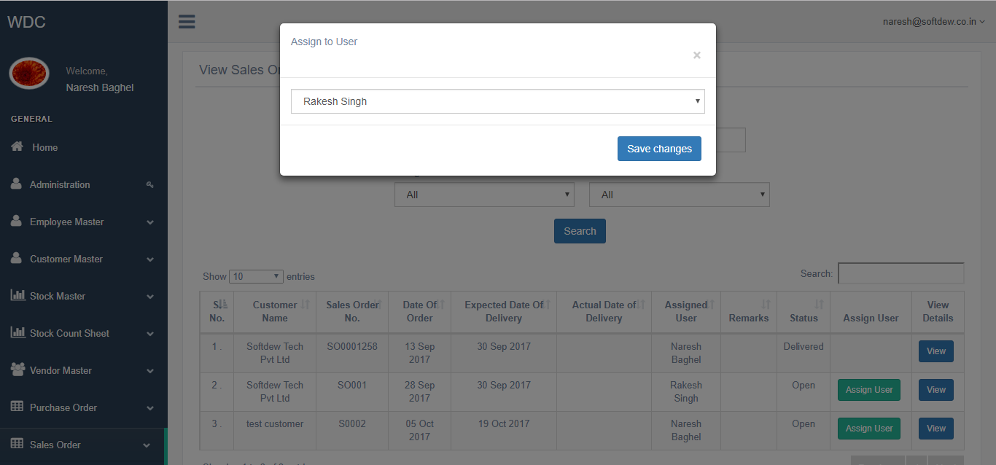

Figure 17 - Assign Sale order to employee

On clicking the Assign User, the pop up will open where admin will select the user from the list and allocate the sales order to that particular user.